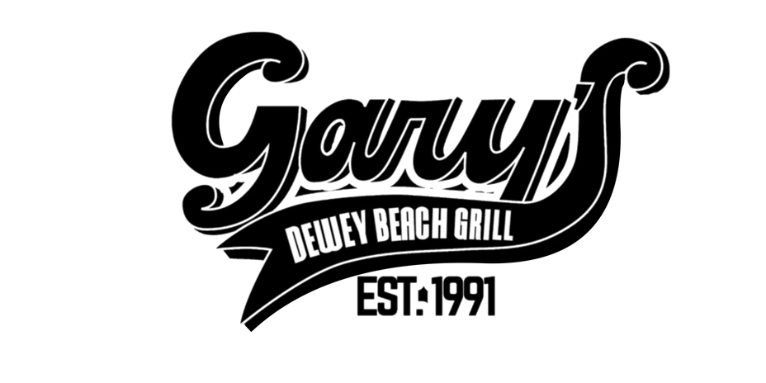
Healthy Kids’ Menu


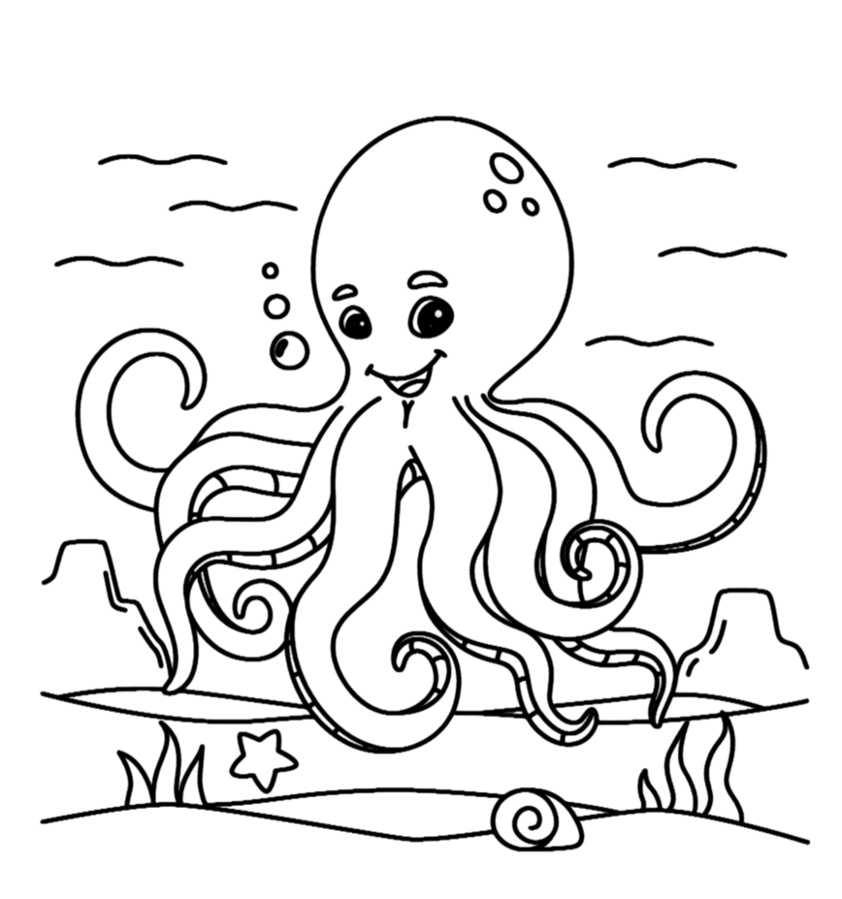
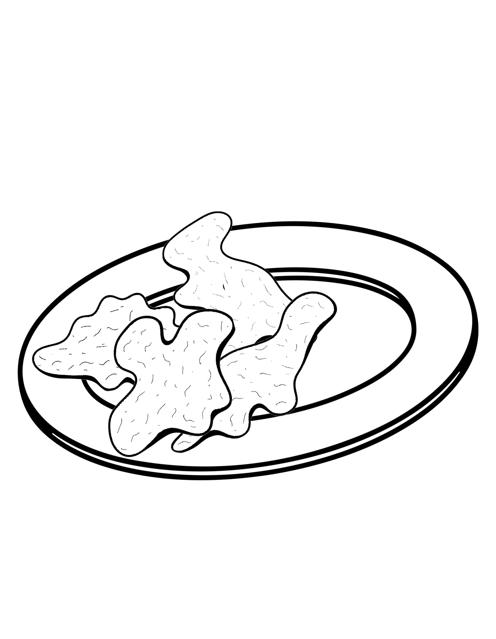

Consuming Raw or Undercooked Meats, Seafood, or Shellfish May Increase Your Risk of Foodborne Illness.

Kids Dinner

(items below only available after 5:00pm)

Crabby Patty Dinner
Two mini Crab Cakes, Wild Rice and grilled Veggies. MKT

Kid's Pasta
Linguine. Choice of Butter or House Marinara. $7
(Parmesan Cheese upon request)

Allergy Warning: Menu Items May Contain or Come into Contact with Meat, Eggs, Soy, Nuts, Milk, and Shellfish.
Ask Our Staff for More Information.

Dino Bites
Dinosaur-Shaped Chicken Nuggets, Grilled, Not Fried. $6

Hot Diggity Turkey Dog
A Healthier Alternative. Grilled, Warm Potato Roll. $5.75
Add Cheese for $1

Kids’ Grilled Cheese
A Smaller Version of Our Classic, Served on Whole Wheat. $5.75

PB & J
Grape Jelly, Creamy Peanut Butter, Whole Wheat. $5.75

Turkey & Cheese
Fresh-Baked Turkey Breast, American Cheese, Whole Wheat. $5.75

Toppings for Sandwiches Available Upon Request.
All Sandwiches Served with Baby Carrots

